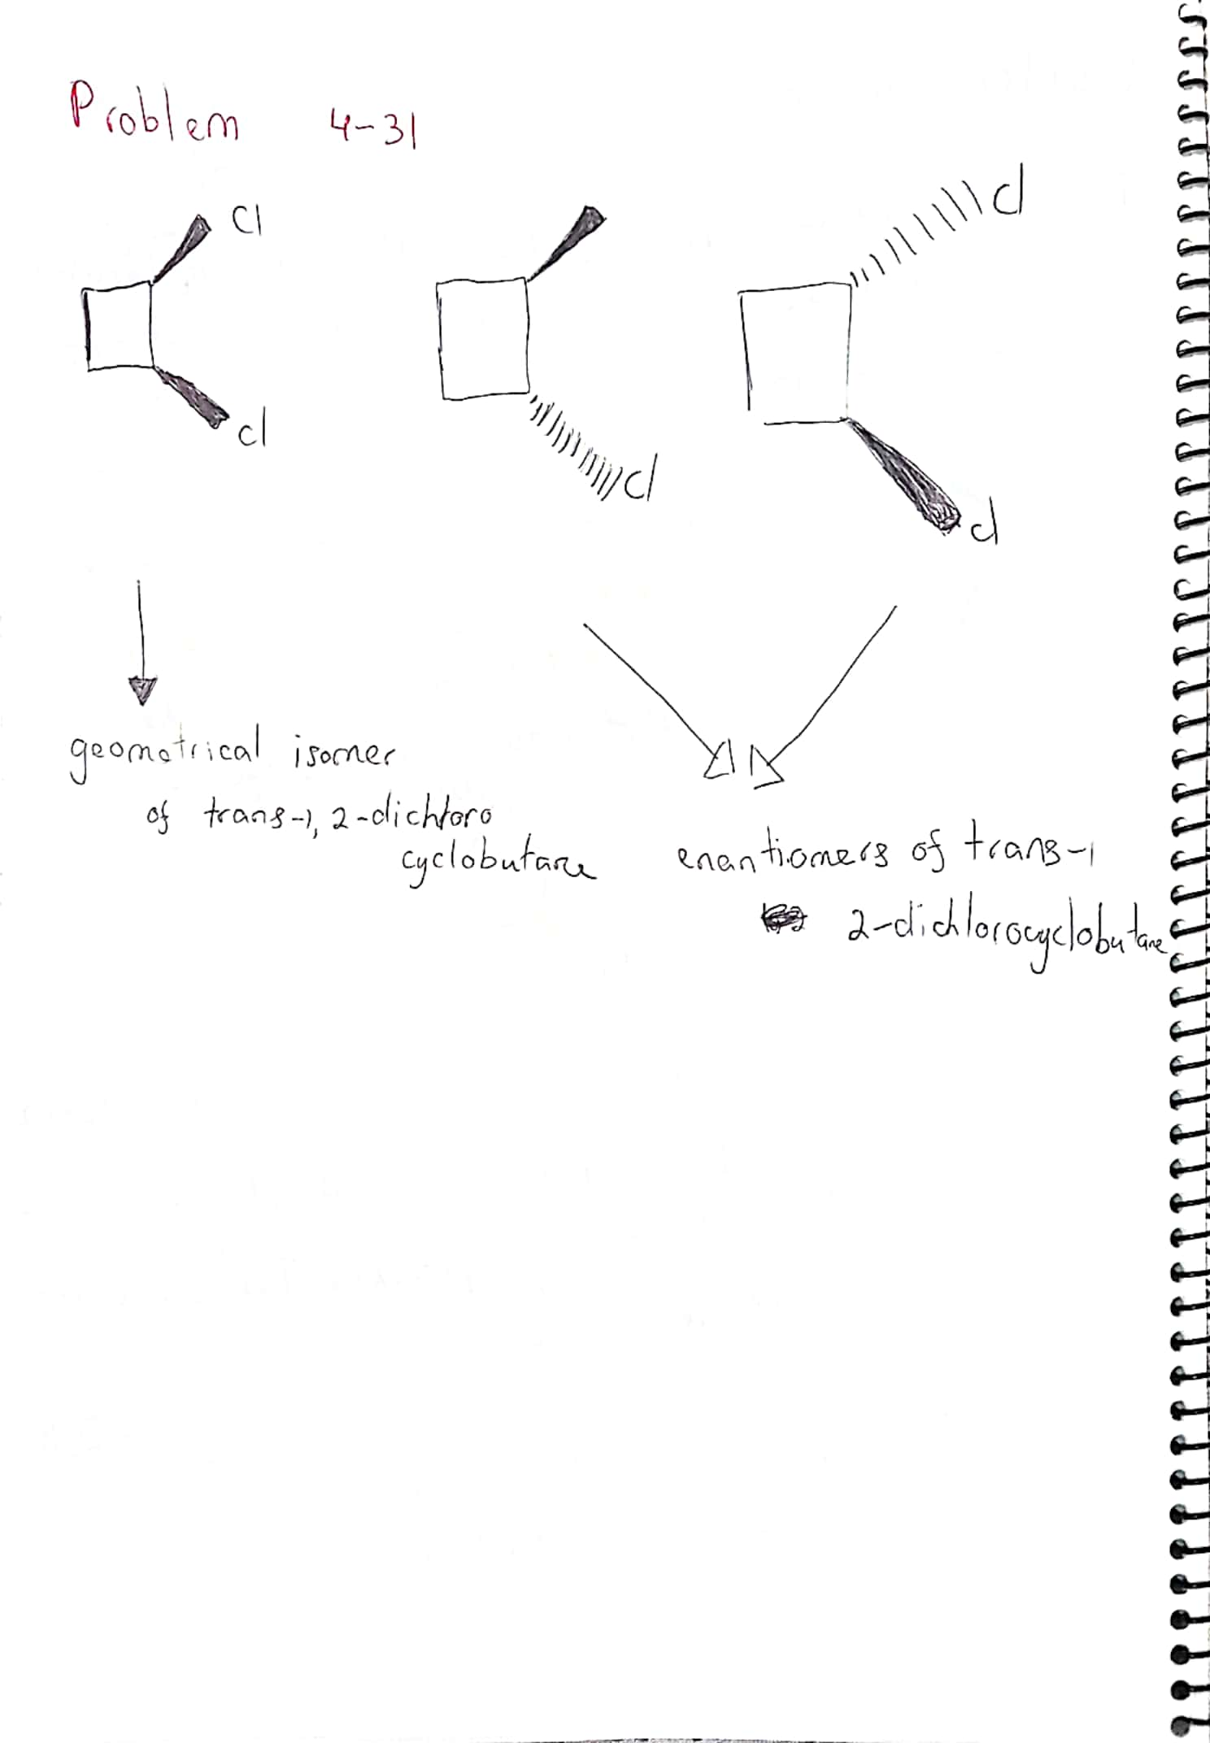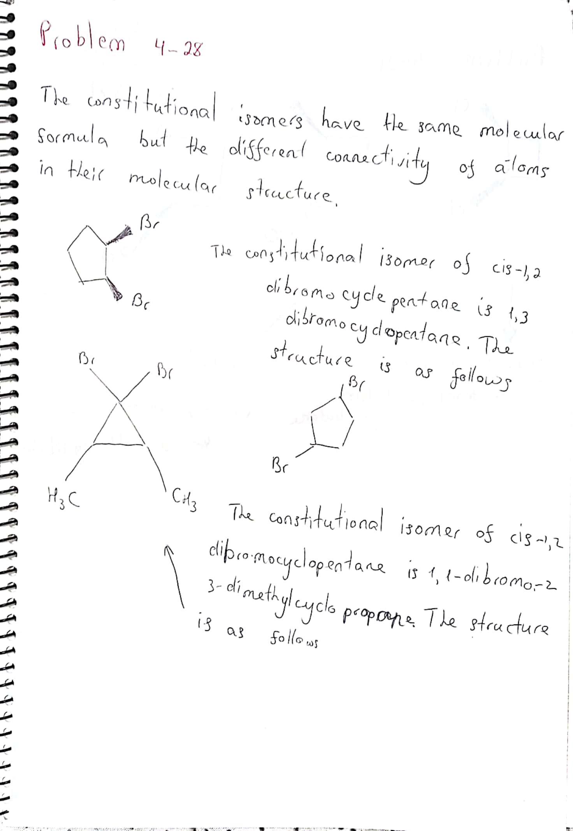

Thank you

Student ID : 201923250

Name : Kobilov Ilkhomjon